Q1.
Key components of RL:
Term | Meaning
Agent | Learner or decision-maker (the entity that takes actions)
Environment | The world the agent interacts with (provides feedback)
State (s) | Current situation or observation of the environment
Action (a) | Choices the agent can make at each state
Reward (r) | Feedback signal (positive/negative) for each action

2. MountainCar Example
The MountainCar environment is a classic RL problem from OpenAI Gym:
Goal: Drive a car up a steep hill.
Challenge: The car’s engine is too weak to climb directly, so the agent must learn to swing back and forth to gain enough momentum.

RL Components in MountainCar:
Component | Example in MountainCar
Agent | The car controlled by the algorithm (e.g., MountainCarAgent)
Environment | MountainCar environment from OpenAI Gym (gym.make("MountainCar-v0"))
State | [position, velocity] of the car at each time step
Action | 0 → push left, 1 → no push, 2 → push right
Reward | Usually -1 at each step until reaching the goal; reaching the flag may give 0 or positive reward

Python Example Snippet
import gymnasium as gym
import numpy as np

# Create environment (new step API)
env = gym.make("MountainCar-v0", render_mode=None) # render_mode=None for headless

state, info = env.reset() # reset now returns (state, info)
done = False

while not done:
action = env.action_space.sample() # Random action: 0 (left), 1 (no push), 2 (right)

# Step now returns: next_state, reward, terminated, truncated, info
next_state, reward, terminated, truncated, info = env.step(action)

done = terminated or truncated # done is True if either terminated or truncated

print(f"State: {state}, Action: {action}, Reward: {reward}, Next state: {next_state}")

state = next_state

Explanation of snippet:
env.reset() → gives initial state [position, velocity].
env.action_space.sample() → chooses a random action.
env.step(action) → moves the agent, returns:
next_state → new state
reward → reward for the action
done → whether the goal is reached
info → extra info

Q2.
Solution:
- gym.make("MountainCar-v0")
- Creates an instance of the MountainCar environment from OpenAI Gym/Gymnasium.
- This environment simulates a car in a valley that the agent must drive up a hill.
- It defines the states, actions, rewards, and physics rules for the task.
- render_mode="human"
- Specifies that the environment should display a graphical window showing the car moving in real time.
- This allows you (the human) to see the agent interacting with the environment.
- Other modes (like render_mode=None) run the simulation without displaying graphics (useful for faster training).
Q3.
Solution:

State Variables in MountainCar-v0
The MountainCar-v0 environment has 2 state variables:
State Variable | Description
Position | The horizontal position of the car along the valley. Typically ranges from -1.2 (left end) to 0.6 (right end, goal). It represents where the car is in the environment.
Velocity | The speed of the car. It can be positive (moving right) or negative (moving left). It represents how fast the car is moving and in which direction.

Q4.
Solution:
The action space defines the possible moves the agent (car) can make in the environment.
- Type: Discrete(3)
There are 3 possible actions.
- Actions and Meaning:
Action | Meaning
0 | Push the car to the left (against the slope)
1 | Do nothing (no force applied)
2 | Push the car to the right (toward the goal)

Q5.
Solution:

Reward Mechanism in MountainCar-v0
Basic Reward Rule:
The agent receives a reward of -1 for each time step until it reaches the goal (the top of the right hill).
Once the car reaches the goal (position ≥ 0.5), the episode ends.
Why Negative Reward at Each Step?
The negative reward acts as a penalty for taking more time.
This encourages the agent to reach the goal as quickly as possible.
Without this penalty, the agent could just move back and forth indefinitely without learning to solve the task efficiently.
Summary of Reward Dynamics:
Condition | Reward
Car has not reached the goal | -1 per step
Car reaches the goal | 0 or positive reward (episode ends)

Effect on Learning:
The agent’s goal is to maximize cumulative reward (or minimize cumulative negative reward).
It learns the best sequence of actions to reach the goal in the fewest possible steps.
Q6.
Solution:
terminated | The episode ended because the agent successfully reached the goal (position ≥ 0.5). This is a natural termination of the task.

truncated | The episode ended because it reached the maximum allowed steps (e.g., 200 steps). This is an artificial termination to prevent infinite loops.

Q7.
Solution:
The agent fails to reach the goal when using action_space.sample() because this method chooses actions completely at random. MountainCar requires the agent to build momentum by moving back and forth strategically to reach the flag. Random actions do not follow this strategy, so the car often wastes steps and cannot reach the goal. To succeed, the agent needs a learned policy that selects actions based on the current state to maximize cumulative reward.
Q8.
Solution:
Momentum is crucial in the MountainCar problem because the car’s engine is too weak to drive directly up the hill. The agent must move back and forth to build enough speed (momentum) to reach the top. By repeatedly pushing left and right, the car gains kinetic energy, which allows it to overcome the hill’s slope. Without using momentum, the car will stall and never reach the goal.
🛠️ Lab Tasks (Hands-on Practice)
🔹 Task 1: Increase Episodes
!pip install gymnasium > /dev/null
import gymnasium as gym
import matplotlib.pyplot as plt
env = gym.make("MountainCar-v0")
episodes = 50
scores = []
for ep in range(episodes):
state, info = env.reset()
done = False
total_reward = 0
while not done:
action = env.action_space.sample()
next_state, reward, terminated, truncated, info = env.step(action)
done = terminated or truncated
total_reward += reward
state = next_state
scores.append(total_reward)
print(f"Episode {ep+1}: Total Reward = {total_reward}")
env.close()
plt.figure(figsize=(10,5))
plt.plot(range(1, episodes+1), scores, marker='o', linestyle='-')
plt.xlabel("Episode")
plt.ylabel("Total Reward")
plt.title("MountainCar: Score Trend Across 50 Episodes (Random Actions)")
plt.grid(True)
plt.show()
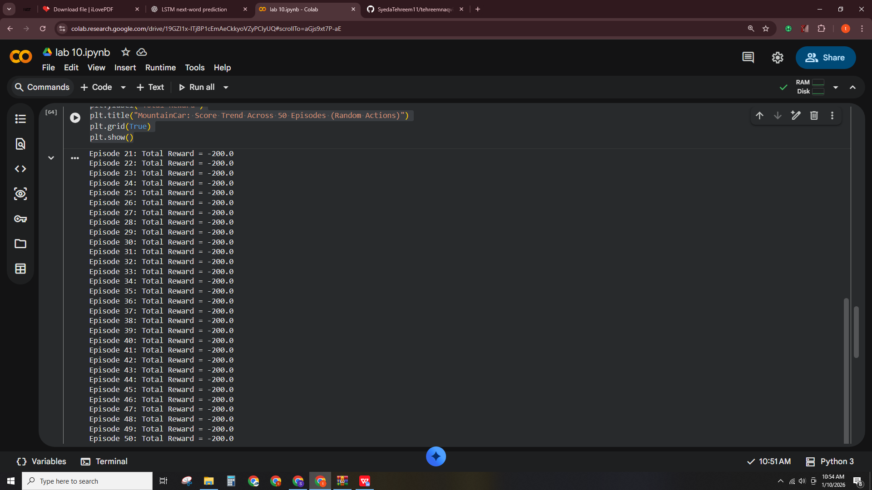
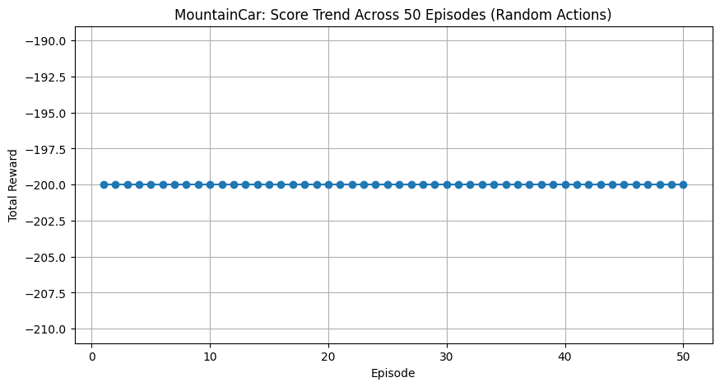
🔹 Task 2: Display State Values
import gymnasium as gym

# Create MountainCar environment
env = gym.make("MountainCar-v0")

# Reset environment
state, info = env.reset()

print("Initial State")
print("State Array:", state)
print("Car Position:", state[0])
print("Car Velocity:", state[1])
print("-" * 40)

done = False
step = 0

while not done:
action = env.action_space.sample() # random action
state, reward, terminated, truncated, info = env.step(action)

done = terminated or truncated

print(f"Step {step}")
print("State Array:", state)
print("Car Position:", state[0])
print("Car Velocity:", state[1])
print("-" * 40)

step += 1

env.close()

Output:
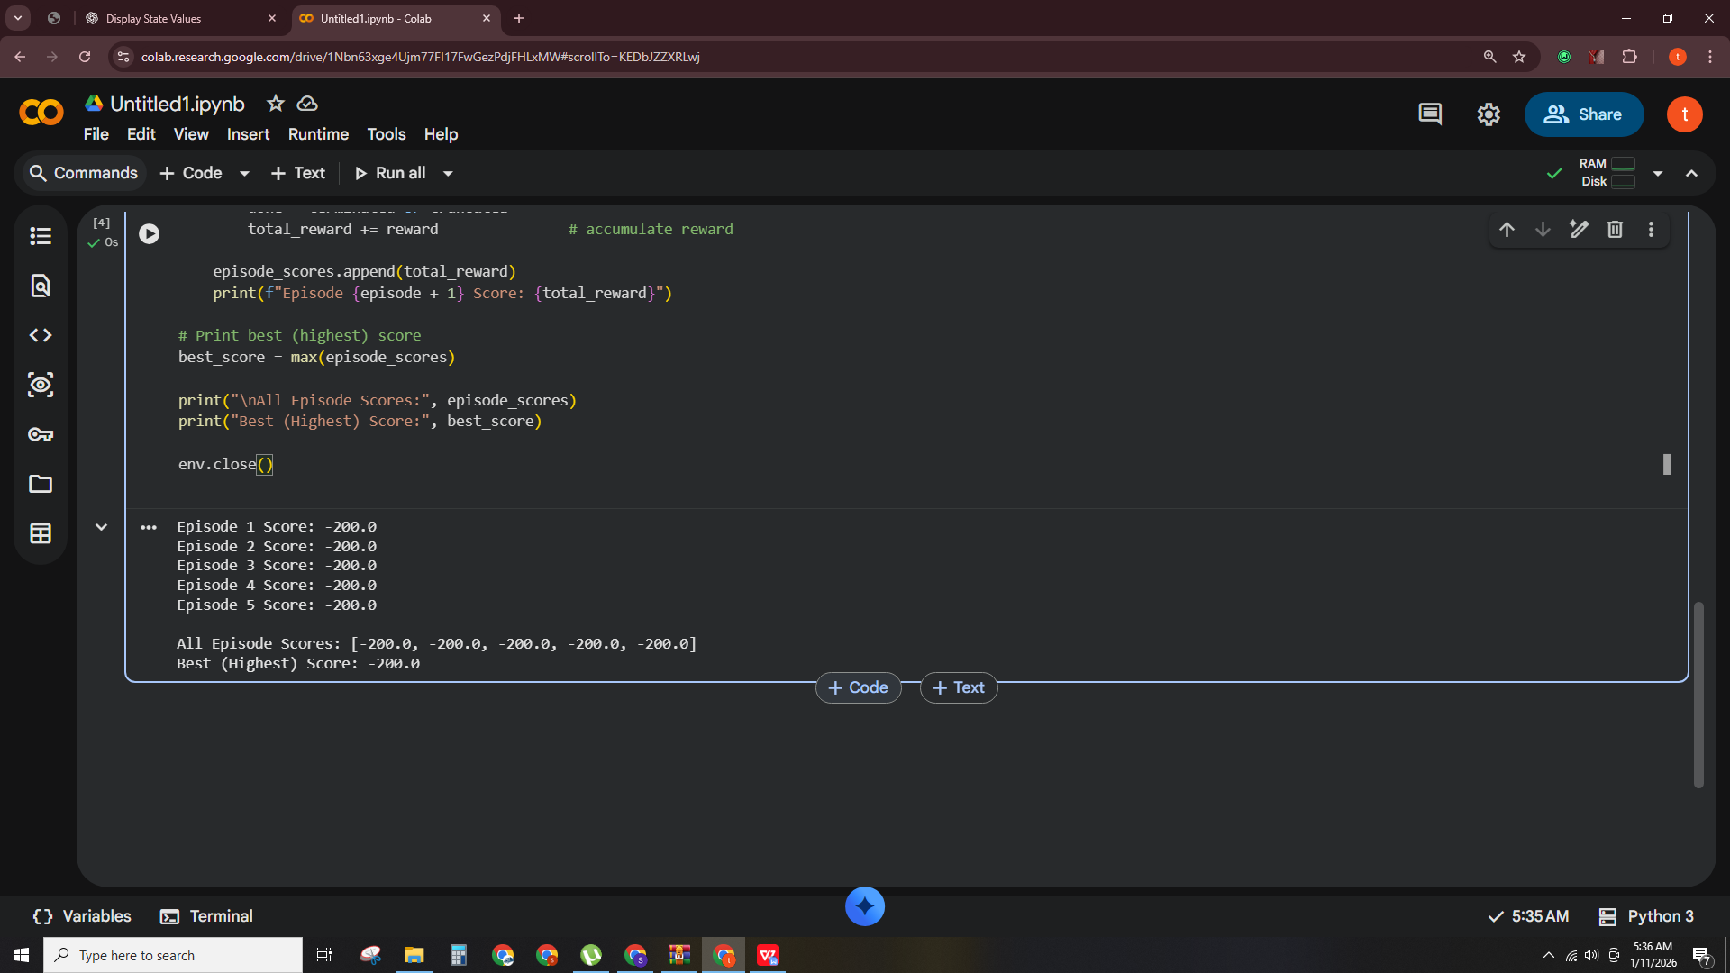
🔹 Task 3: Change Text Color & Location
import matplotlib.pyplot as plt
plt.figure(figsize=(6, 4))
plt.text(
200, 20,
"Score: 100",
color="blue",
fontsize=12
)
plt.xlim(0, 400)
plt.ylim(0, 200)
plt.axis("off")
plt.show()

Output:
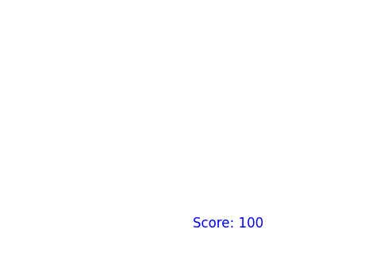
🔹 Task 4: Track Best Performance
!pip install gymnasium[classic-control]

import gymnasium as gym

# Create environment
env = gym.make("MountainCar-v0")

num_episodes = 5 # number of episodes
episode_scores = [] # list to store scores

for episode in range(num_episodes):
state, info = env.reset()
done = False
total_reward = 0

while not done:
action = env.action_space.sample() # random action
state, reward, terminated, truncated, info = env.step(action)

done = terminated or truncated
total_reward += reward # accumulate reward

episode_scores.append(total_reward)
print(f"Episode {episode + 1} Score: {total_reward}")

# Print best (highest) score
best_score = max(episode_scores)

print("\nAll Episode Scores:", episode_scores)
print("Best (Highest) Score:", best_score)

env.close()

Output:
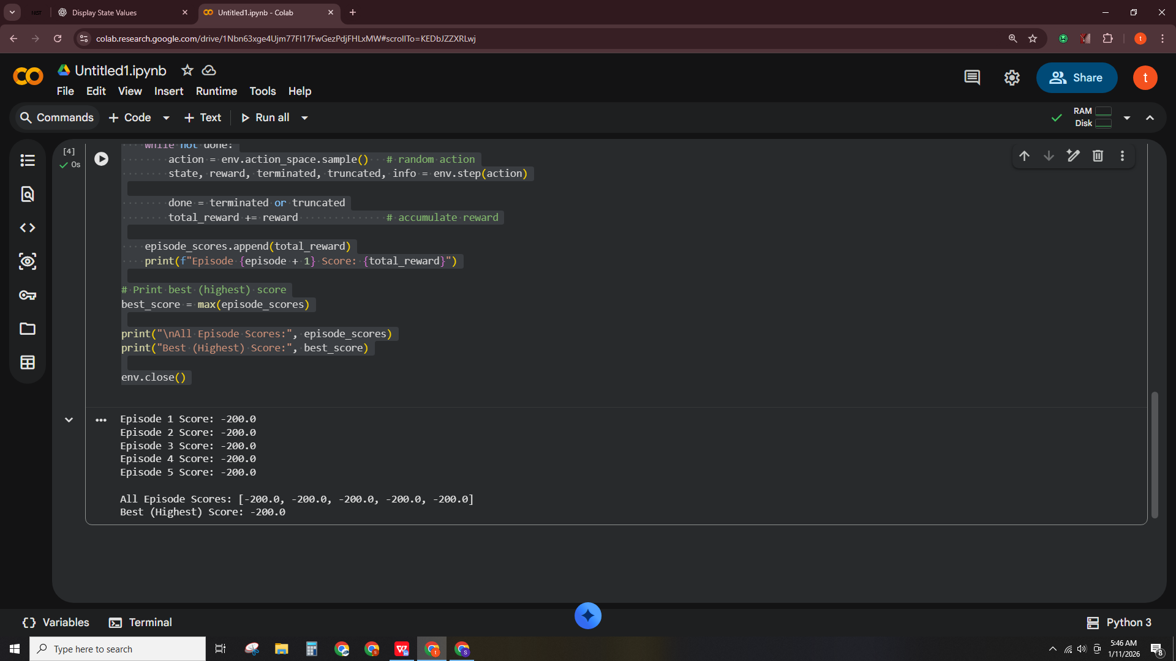
🔹 Task 5: Slow Down Visualization
!pip install pygame
import os
os.environ["SDL_VIDEODRIVER"] = "dummy" # prevents display crash in Colab
import pygame
import time

# Initialize pygame
pygame.init()

print("Starting loop with delay...\n")

for step in range(10):
start_time = time.time()

# ---- YOUR REQUIRED LINE ----
pygame.time.delay(20) # slows down loop by 20 milliseconds

end_time = time.time()
elapsed_time = (end_time - start_time) * 1000 # convert to ms

print(f"Step {step} | Time taken: {elapsed_time:.2f} ms")

pygame.quit()

Output:
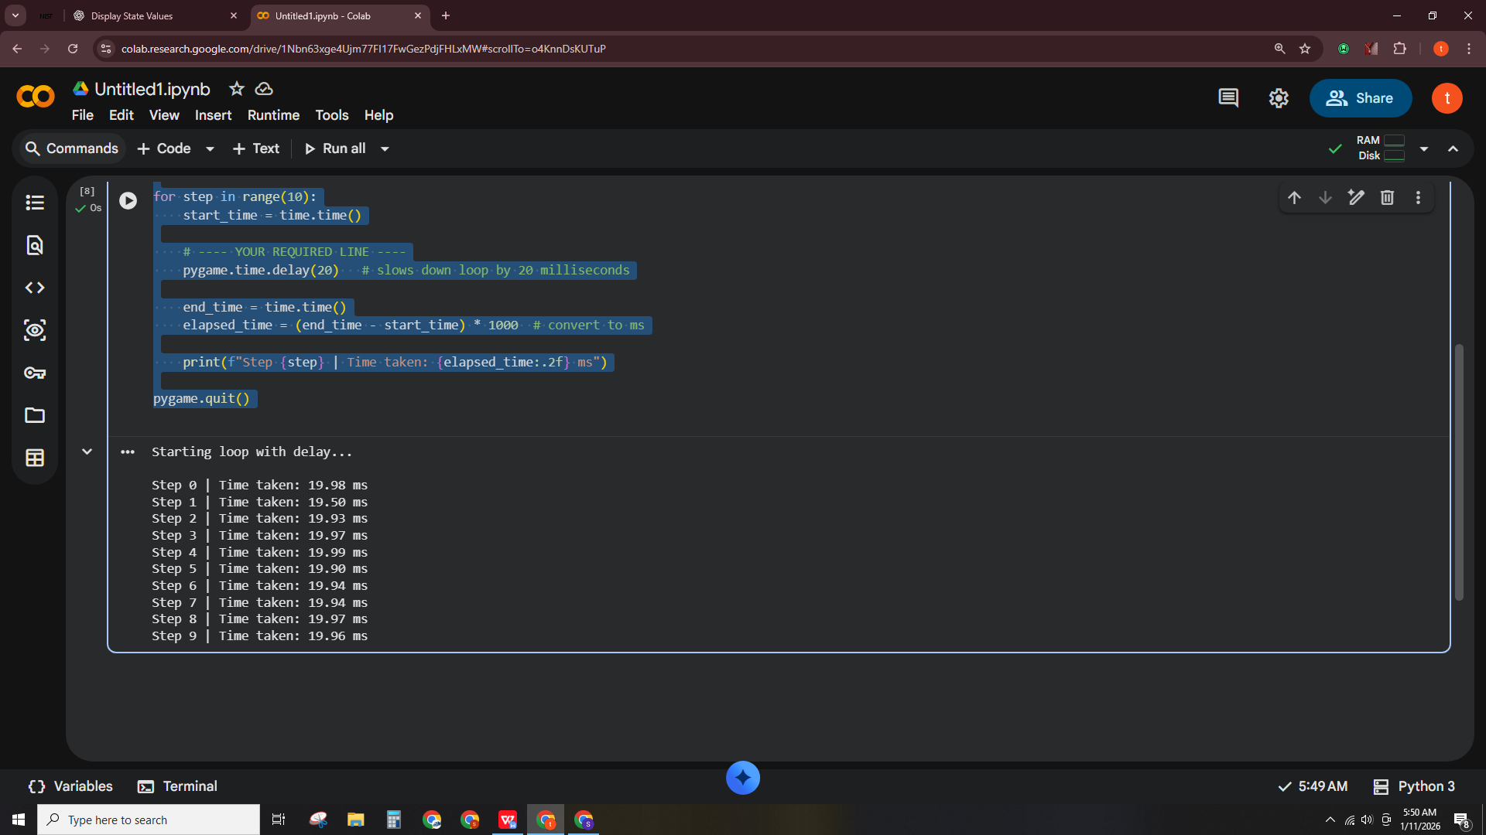
🔹 Task 6: Compare with CartPole

Code:
!pip install gymnasium[classic-control]

import gymnasium as gym

# Create CartPole environment (NO human render in Colab)
env = gym.make("CartPole-v1")

num_episodes = 5

for episode in range(num_episodes):
state, info = env.reset()
done = False
total_reward = 0

while not done:
action = env.action_space.sample()
state, reward, terminated, truncated, info = env.step(action)

done = terminated or truncated
total_reward += reward

print(f"Episode {episode + 1} Total Reward: {total_reward}")

env.close()

Output:
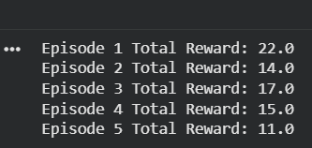
🔹 Task 7: Simple Rule-Based Policy (Intermediate)
import gymnasium as gym

# Create MountainCar environment
env = gym.make("MountainCar-v0")

num_episodes = 5

for episode in range(num_episodes):
state, info = env.reset()
done = False
total_reward = 0
steps = 0

while not done:
# ----- RULE-BASED POLICY -----
if state[1] > 0:
action = 2 # push right
else:
action = 0 # push left

state, reward, terminated, truncated, info = env.step(action)

done = terminated or truncated
total_reward += reward
steps += 1

# Check if hilltop reached
reached_goal = state[0] >= 0.5

print(f"Episode {episode + 1}")
print("Steps:", steps)
print("Total Reward:", total_reward)
print("Final Position:", state[0])
print("Reached Hilltop:", reached_goal)
print("-" * 40)

env.close()

Output:
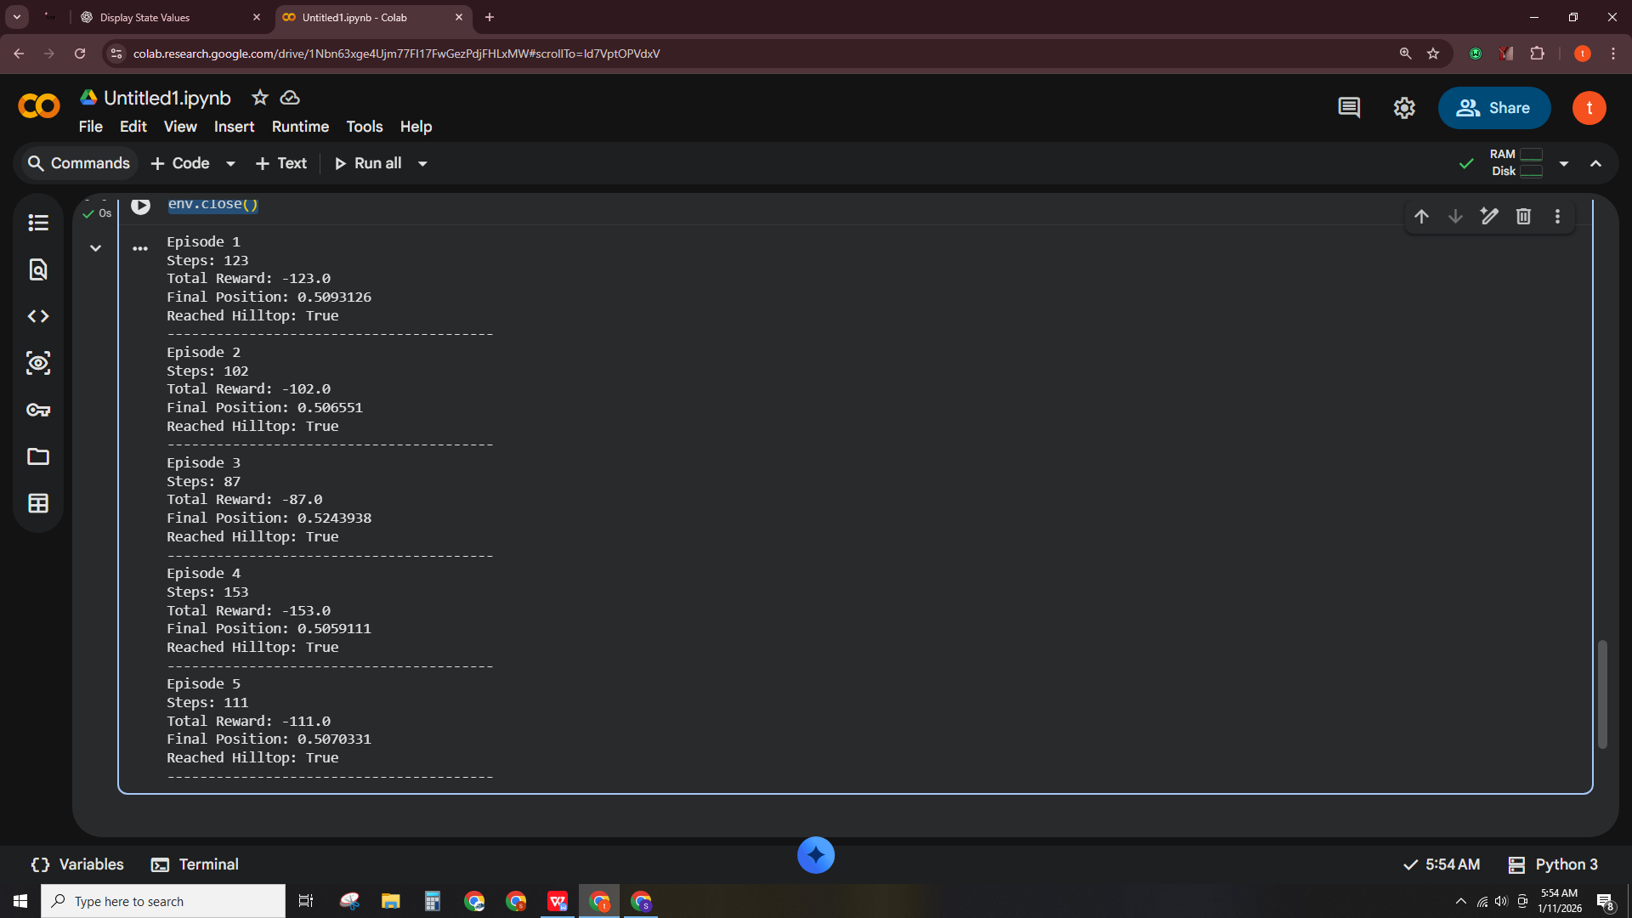
🔹 Task 8 (Advanced): Episode Length Analysis
Code:
import gymnasium as gym
import pandas as pd

env = gym.make("MountainCar-v0")

num_episodes = 20

# Lists for observation table
episodes = []
steps_list = []
scores = []
goals = []

for episode in range(1, num_episodes + 1):
state, info = env.reset()
done = False
total_reward = 0
steps = 0

while not done:
# Rule-based policy (from Task 7)
if state[1] > 0:
action = 2
else:
action = 0

state, reward, terminated, truncated, info = env.step(action)
done = terminated or truncated

total_reward += reward
steps += 1

# Goal check
goal_reached = "Yes" if state[0] >= 0.5 else "No"

episodes.append(episode)
steps_list.append(steps)
scores.append(total_reward)
goals.append(goal_reached)

# Create Observation Table
observation_table = pd.DataFrame({
"Episode": episodes,
"Steps": steps_list,
"Score": scores,
"Goal Reached (Yes/No)": goals
})

observation_table

Output:
